Ballast Pit

https://maps.app.goo.gl/b8u93oBTbHpUAcnHA?g_st=ic

Parking
Barnageeragh Rd beside Pitch
https://maps.app.goo.gl/b8u93oBTbHpUAcnHA?g_st=ic

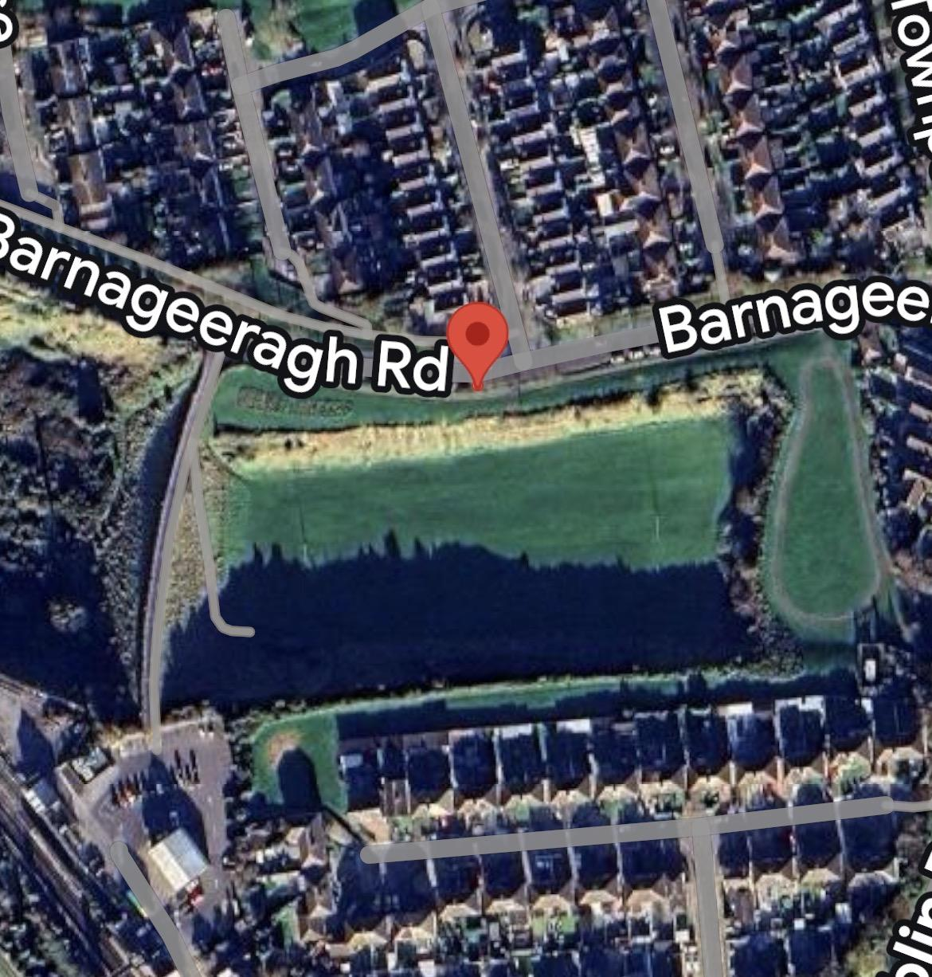

Toilets
Unfortunately none available at Pitch
Use Harps Club House or Community Centre.

